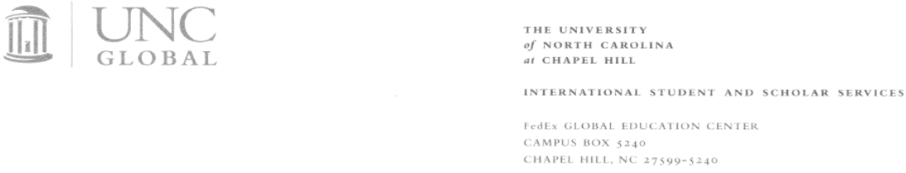

TRAINING PLAN FOR STEM OPT STUDENTS UNC SUPERVISOR CERTIFICATION

STEM OPT Student Name: Click here to enter text.
Site Name (Department): Click here to enter text.
Supervisor Name & Title: Click here to enter text.

Science, Technology, Engineering, & Mathematics (STEM) Optional Practical Training (OPT) is regulated by U.S. Immigration and Customs Enforcement (ICE) and the Department of Homeland Security (DHS). NOTE: DHS may, at its discretion, conduct a site visit of the employer to ensure that program requirements are being met, including that the employer possess and maintains the ability and resources to provide structured and guided work-based learning experiences consistent with the Training Plan for STEM OPT Students (Form I-983). Information is available at https://studyinthestates.dhs.gov/stem-opt-hub
CERTIFICATION BY THE UNC SUPERVISOR FOR FORM I-983

By initially each section and signing below, I certify as the supervisor of the above-mentioned F-1 student that:
_______Form I-983, Section 5: Training Plan for STEM OPT Students for the above-mentioned F-1 student has been prepared under my guidance and is approved by me;
_______I have reviewed and understand this Plan, and I will ensure that as the Supervising Official I will follow this Plan;
_______I will notify the Human Resources Officer to notify the Designated School Official (DSO) at the STEM OPT student’s home university at the earliest available opportunity regarding any material changes to this Plan, including but not limited to, any reduction in compensation from the amount previously submitted on the Plan that is not tied to a reduction in hours worked, any significant decrease in hours per week that a student engages in a STEM training opportunity, and any decrease in hours below the 20-hours-per-week minimum required under the STEM OPT rules; All changes of employment must be approved through appropriate channels (e.g. HR, Office of Postdoctoral Affairs, etc.);
_______Within five business days of the termination or departure of the student during the authorized period of OPT, I will report such termination or departure to the HR Officer for report to the DSO (Note: business days do not include federal holidays or weekend days; and an employer shall consider a student to have departed when the employer knows the student has left the practical training opportunity, or when the student has not reported for practical training for a period of five consecutive business days without the consent of the employer); and
_______I will adhere to all applicable regulatory provisions that govern this program (see 8 CFR Part 214), which include, but are not limited to, the following:
_______The student’s practical training opportunity is directly related to the STEM degree that qualifies the student for the STEM OPT extension, and the position offered to the student achieves the objectives of his or her participation in this training program;
_______The student will receive on-site supervision and training, consistent with this Plan, by experienced and knowledgeable staff;
_______Sufficient resources and personnel are available to provide the specified training program set forth in this Plan, and I am prepared to implement that program, including at the location(s) identified in this Plan;
_______The student on a STEM OPT extension will not replace a full- or part-time, temporary or permanent U.S. worker;
_______The training conducted pursuant to this Plan complies with all applicable Federal and State requirements relating to employment;
_______I understand that the student must submit the Evaluation on Student Progress at the 12 month and the Final Evaluation on Student Progress at the 24 month point in STEM OPT. I will review the self-evaluation and submit it to the HR Officer for to request the Employer Official with Signatory Authority’s signature; and
_______I understand that the student is also required to submit validation reports to the DSO every 6 months.
I declare and affirm under penalty of perjury that the statements and information made herein are true and correct to the best of my knowledge, information and belief. I understand that the law provides sever penalties for knowingly and willfully falsifying or concealing a material fact, or using any false document in the submission of this form and Form I-983.

Title 18 of the United States Code, Chapter 47, Section 1546 states:
“Whoever knowingly makes under oath, or as permitted under penalty of perjury under section 1746 of title 28, United States Code, knowingly subscribes as true, any false statement with respect to a material fact in any application, affidavit, or other document required by the immigration laws or regulations prescribed there under, or knowingly presents any such application, affidavit, or other document which contains any such false statement or which fails to contain any reasonable basis in law or fact - shall be fined under this title or imprisoned not more than 10 years (in the case of the first or second such offense), or 15 years (in the case of any other offense), or both.“

Name of Principal Investigator/Supervisor: Click here to enter text.
Signature of Principal Investigator/Supervisor: _________________________ Date: _____________

STEM OPT Student Name: Click here to enter text. Department: Click here to enter text.

